**EITS Sales Representative User Guide**

**Official Link:** <https://m.eitsdubai.com/login>

**User Crendentials:**

**Sales Representative:**

**Username(email):** sales_rep@eits.com

**Password:** sales_rep@eits

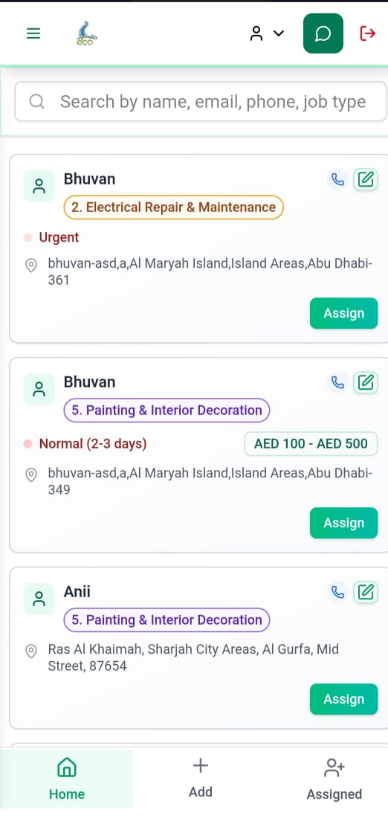

* This is the main page of Sales dashboard, in search bar sales representative can search all the required work from user, can click on card for detailed information, can edit the information according to client requirement.

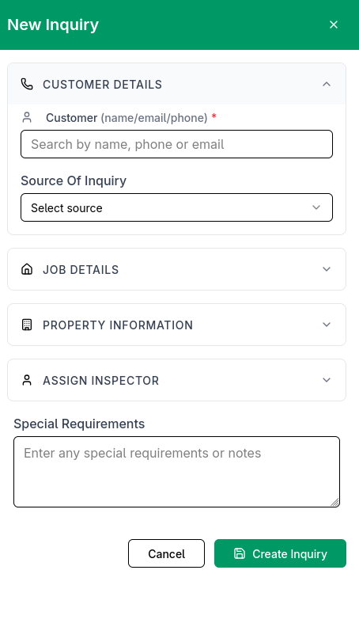

**Add Inquiry Section**

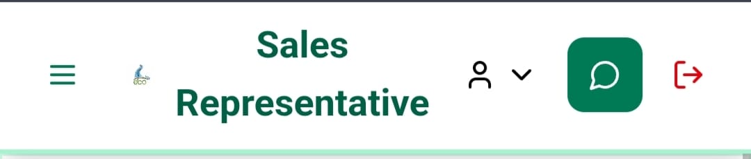

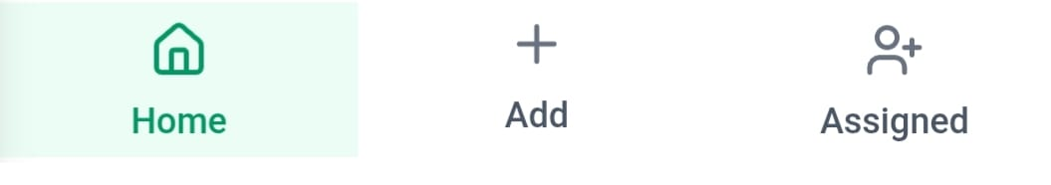 **OR**

* Click on **Plus** **icon** or **Hamburger** **Icon** (Three Lines) on main page to add the new details about work and the process is same as edit inquiry.

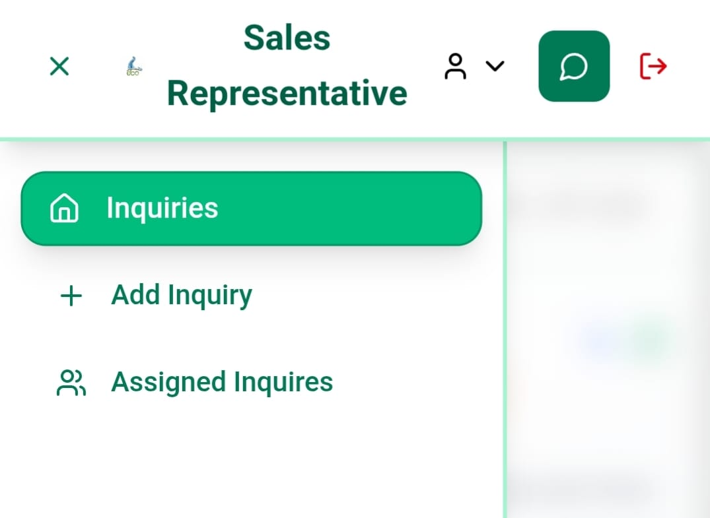

* After click on Three lines this side bar will appear, you can choose any these to proceed with **Add** **Inquiry** or **Assigned** **Inquiry.**

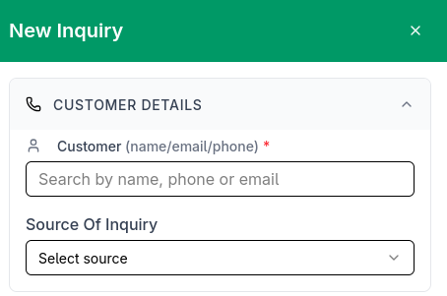

* Now in the Customer details Section you just have to search customer name and all the related information will fill automatically.

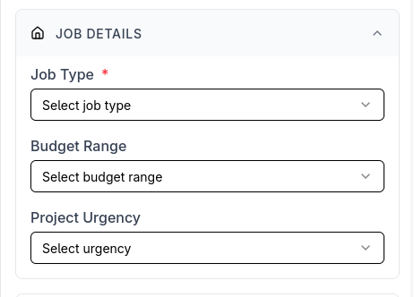

**Job Details**

* In Job details Section Representative can add all the job type according to client requirement, and also add budget, and how fast it need to be done as shown in above picture.
* Property information will also fill automatically as per the data of customer

**Assign Inspector Section**

Overview

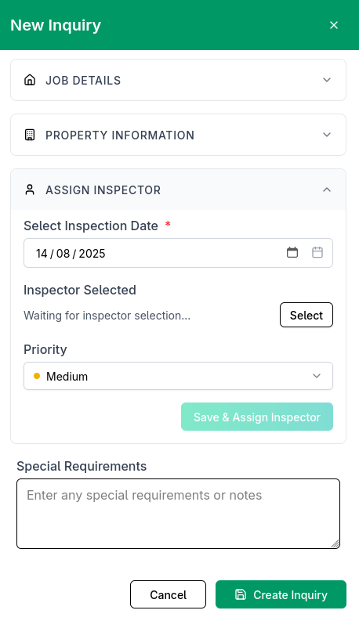

The **"Assign Inspector"** section allows you to:

* **Select an inspector** from available personnel
* **Schedule an inspection date**
* **Specify time slots** based on inspector availability
* **Add special requirements** if needed

Fields Explained

1. **Select Inspection Date** *(Required)*

* **Purpose**: Choose the date for the inspection.
* **Format**: *Day/Month/Year* (e.g., **14/08/2025**).
* **Note**: Marked with an asterisk (*), meaning it is mandatory.

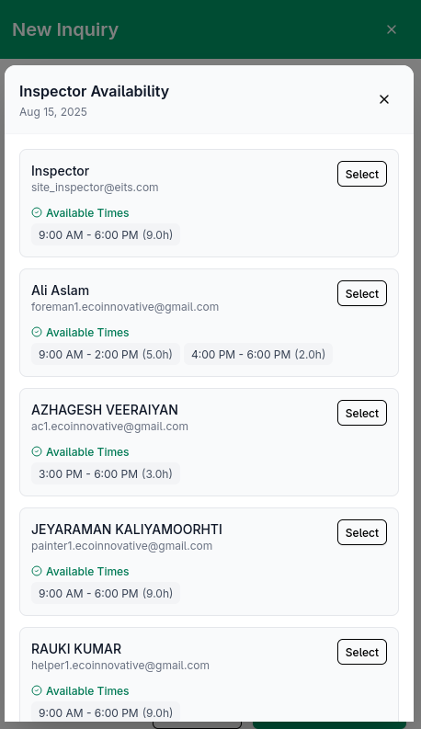

2. **Inspector Availability**

After selecting a date, available inspectors and their time slots appear:

***Inspector Details***

* **Name & Email**: Identifies the inspector (e.g., *Ali Aslam –* foremani.ecoinnovative@gmail.com).
* **Available Times**:
  + Displays time slots (e.g., *9:00 AM - 2:00 PM*).
  + Total working hours are shown in brackets (e.g., *5.0h*).
* **Select Button**: Click to assign the inspector.

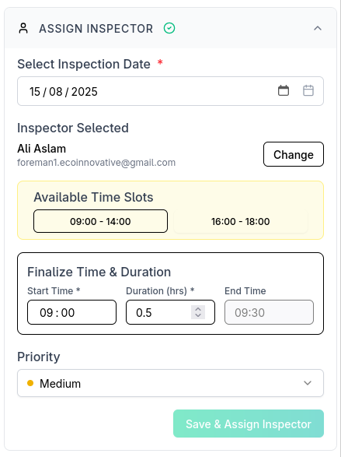

**Finalize Time & Duration Section**

**Fields & Actions**

1. **Available Time Slots (Yellow Highlighted Box)**
   * Displays the inspector's pre-set availability windows (e.g., **09:00–14:00, 16:00–18:00**).
   * **Action**: Click a slot to auto-fill the **Start Time** and adjust the **Duration**.
2. **Start Time (***Required***)**
   * **Purpose**: Set the exact inspection start time within the selected slot.
   * **Format**: **HH:MM** (e.g., 09:00).
   * **Constraint**: Must fall within the chosen availability window.
3. **Duration (***Required***)**
   * **Purpose**: Define inspection length (in hours).
   * **Example**: 0.5 = 30 minutes, 2.0 = 2 hours.
   * **Auto-Calculation**: **End Time** updates dynamically (e.g., 09:00 + 0.5 hrs = 09:30).
4. **Priority**
   * **Options**: **Medium** (default ✔), *High/Low* (if available).
   * **Purpose**: Indicates scheduling urgency.
5. **"Save & Assign Inspector" Button**
   * **Action**: Confirms the booking.
   * **Requirement**: All fields marked (*) must be filled.

**Key Notes**

* ⚠ **Slot Constraints**: Start/End times **must** stay within the highlighted availability.
* 🔹 **Tip**: Double-check times before saving. Use **Priority** for urgent cases.

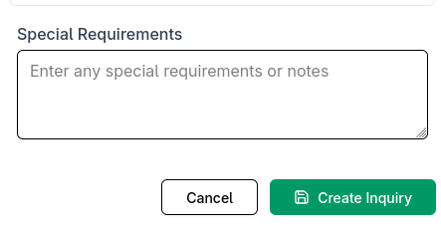

3. **Special Requirements** *(Optional)*

* **Purpose**: Add notes for the inspector (e.g., *"Check roof for leaks"*).

4. **Action Buttons**

* **Save & Assign Inspector**: Confirms the assignment.
* **Cancel**: Discards changes and exits.
* **Create Inquiry**: Finalizes the entire inquiry process.

Step-by-Step Process

1. **Pick a date** in the *Select Inspection Date* field.
2. **Review inspector availability**:
   * Each inspector’s time slots are listed.
   * Select one by clicking the **"Select"** button next to their name.
3. **Add notes** in *Special Requirements* if needed.
4. Click **"Save & Assign Inspector"** to confirm.
5. Finally, click **"Create Inquiry"** to complete the process.

Best Practices

✔ **Verify inspector availability** before assigning.  
✔ **Choose time slots** that align with tenant/property availability.  
✔ **Provide clear instructions** in *Special Requirements* if necessary.  
✔ **Double-check selections** before finalizing.

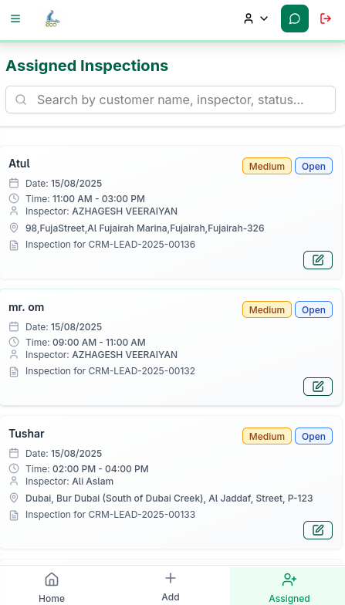

Finally the assigned Inquiry will be visible on “Assigned” Tab.

You can edit the Inquiry by updating the assigned Inspector by following the same steps provided earlier.

**Document Title:** EITS Sales Representative User Guide

* **Package Number:** 001
* **Author:** Kartik Kumar, Atul Raj
* **Approved By:** Amit Gupta
* **Created Date:** [14/08/2025]
* **Last Updated:** [14/08/2025]
* **Version:** 1.0.0
* **Status:** Draft
* **Confidentiality Level:** Internal Use
* **Developed at:** Gennext IT Management & Consulting